Chapter 2 Specification Requirement

2.1 Feature 1
Feature 1: Daily Briefing System
The Daily Briefing System automatically captures and summarizes Thai news from approved government and mainstream media sources, providing bilingual (Chinese/English) access to daily news briefings for User. At 8 a.m. every day, the system captures news from the pre-approved websites of the Thai government/mainstream media (Bangkok Post, The Nation Thailand), and saves each article as a Daily Briefing record, including original title, summary generated by the system call Qwen Ai to summarize, source website name, original URL, publication time provided by the source, crawl timestamp. The system generates both Chinese and English versions for the title and abstract, and the interface only displays one of them in the current language. When the User opens the Daily Briefing page, the system returns a paginated list of Daily Briefing record from new to old according to the release time. The list card displays: title, summary, source, publication time (using only the current interface language), and provides a button to enter the detail page. User can also click original button to opens the original URL of the news. Users can enter any keywords in the search box on the page. System searches by keyword among Daily Briefing titles and abstracts (both Chinese and English versions) in the database,then System returns Daily Briefing items related to that word in the current language
User can set filtering conditions: start date(day-month-year), end date(day-month-year), and source (selected from the predefined Bangkok Post, The Nation Thailand list). The system applies all filtering conditions, only returns the Daily Briefing news that meets the conditions, and displays them in chronological order(new to old).

2.1.1 Use Case Diagram
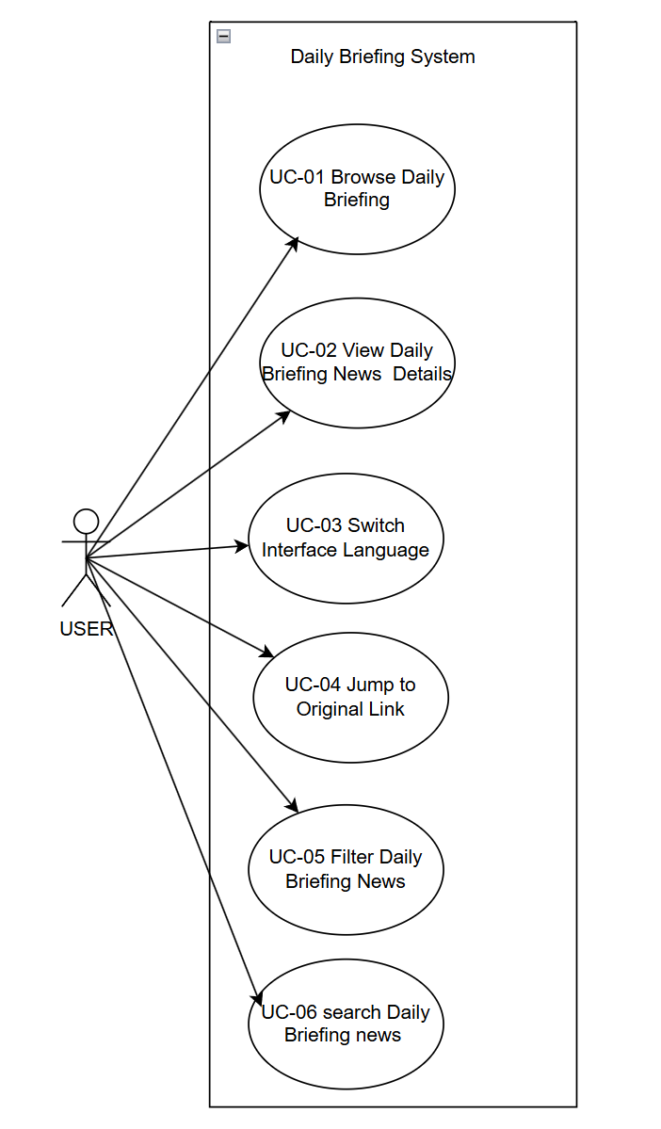

2.1.2 User Requirement Specification
URS-01 – Browse Daily Briefings
User can open the Daily Briefing page and browse a paginated list of recent Daily Briefing items ordered from newest to oldest by publication time in their current interface language.
URS-02 – View Daily Briefing news details
User can select a Daily Briefing item from the list and view a news detail page that shows the complete information (title, summary, publication time, crawl time, View Original button) for that item in their current interface language (English/Chinese).
URS‑03 – Switch Interface Language
User can click a language switch button at any time to change the interface language between Chinese and English and continue browsing Daily Briefing items in the newly selected language.
URS‑04 – Jump to the original link
User can click an “Open original article” button on a Daily Briefing item and read the full original news article on the external official website in a new browser tab.
URS‑05 – Filter Daily Briefings News
User can filter Daily Briefing items by choosing a start date, an end date, and news sources from a predefined list(Bangkok Post, The Nation Thailand), and then browse only the items that meet these filter conditions.
URS-06 – Search for Daily Briefing News
User can type Chinese or English keywords into a search box on the Daily Briefing page and view only Daily Briefing items that match the entered keywords.

2.2 Feature2
Feature 2: Community Interaction
This community Interaction where users can create, browse, and interact with posts through likes, comments, and private messaging, with Qwen AI-powered automatic translation, content moderation, and comment summarization to ensure safe and accessible communication in both Chinese and English. There are five community Interaction (Study, Housing, Travel, Part-time Job, Life Services) in the community Interaction.
User can open the community page and see the stream of post which post time from new to old. Scrolling down will load more posts. Each post card shows title, preview of the main text, selected tags (Study, Housing, Travel, Part-time Job, Life Services), number of likes, and number of comments. User can enter Chinese/English keywords. The system will search in all post titles and body texts (in both Chinese and English versions) and only return the list of matching posts. For user who follow each other, both sides will appear in each other's mutual follow list. Open the mutual follow list, you can sending a private message directly to the author.
User can search for the names of those they follow, view their profiles(name,their posts), send private messages directly from the list or unfollow those they already follow.User can open existing one-on-one private messages or create new one-on-one private messages, send and receive messages with mutual followers, and view the history in the conversation interface.Mark the session as read/unread in the session list, or delete the entire session so that it no longer appears in the list.
User can create or edit their own posts: enter Chinese/English titles and text, upload pictures, and select tags (such as Learning). When submitting for release, the system will call Qwen Ai to automatically translates and generates another language version and conducts a content security review by Qwen AI.
Users can click on post to enter the post details page. On the post detail page, User can view the full text about this post, pictures, tags(such as learning), total number of likes, total number of comments. Clicking on the author's avatar can show the author's profile(avatar,name,author’s posts). The detail page also supports subsequent operations: liking(click “like” button to like post), commenting (User can enter Chinese/English comments under a certain post, along with the commenter's name and timestamp. User can also delete the comment you have already published), reporting post - in the reporting form, select one or more predefined reasons (Spam, Fraud or Scam, Illegal Service Promotion, Abusive Language, Other), and you can fill in the explanatory text. After submission, it enters the subsequent review (the Qwen AI will judge the post/comment pass or not). There is an "AI Summary" button next to the comment. After clicking it, users can view the summaries of all comments under the post in their chosen language

2.2.1 Use Case Diagram
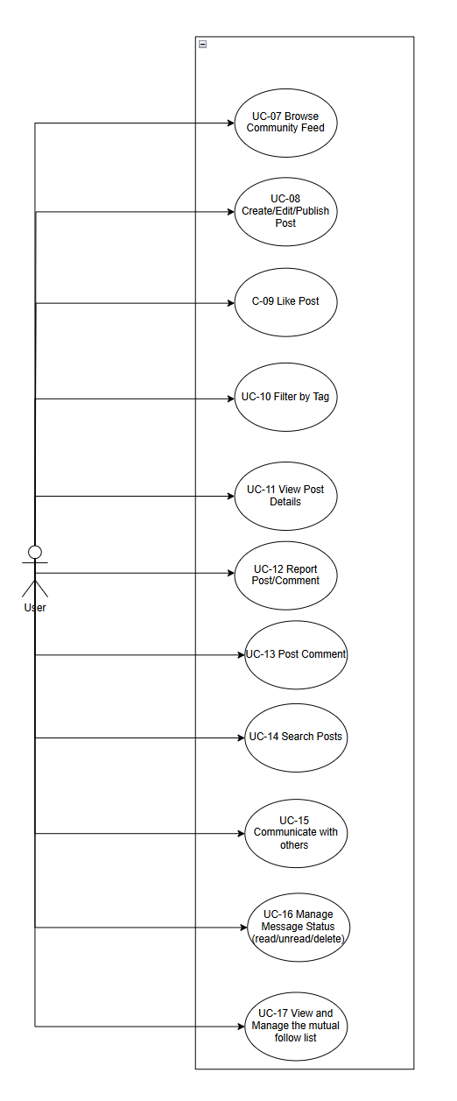

2.2.2 User Requirement Specification
URS‑07 – Browse Community Feed
User can open the community page and view a continuously updated feed of approved community posts authored by user ordered from newest to oldest by publication time, where each post card shows the title, a preview of the body text, selected tags(Study, Housing, Travel, Part-time Job, Life Services), the number of likes, and the number of comments.
URS‑08 – Create/Edit/Publish Community Post
User can create a new community post or edit one of their existing posts.
User can enter the post title and body in either Chinese or English, upload images, and choose tags (such as “Learning”) from the predefined tag list.
User can submit the post for publishing, and the post is published to the community feed only after it satisfies the Qwen AI check
URS‑09 – Like Post
User can express positive feedback on a specific community post by clicking a like button, and they can see the like count on the post updated accordingly.
URS‑10 – Filter by Tag
User can focus on posts belonging to specific topics by selecting tags from the predefined tag list (for example “Study”, “Housing”, “Travel”, “Part‑time Job”, “Life Services”).
After User select tags, they can see the community feed showing only posts that contain at least one of the selected tags.
URS‑11 – View Post Details
User can open a single community post from the feed and see the full body text, all images, the tags (such as “Learning”), detailed engagement metrics (total likes and total comments), and a link to the author’s profile.
User can click on the author's avatar to view the author's profile (avatar, name, author's posts).If user have a mutual-follow relationship with the author, they can send a private message directly to the author from the post detail page.
Users can click the "AI Summary" button to view the summary of all comments under the post in the language of their choice
URS‑12 – Report Post/Comment
User can submit reports about suspected spam, fraud, illegal service promotion, or abusive language on a specific community post or comment.
User can choose one or more predefined report reasons, such as “Spam”, “Fraud or Scam”, “Illegal Service Promotion”, “Abusive Language”, or “Other”, and can optionally enter additional description text.
URS‑13 – Post Comment
User can add comments under a selected community post.
User can enter the comment text in Chinese or English and submit it, and then they can see the new comment appearing in the comment list below the post together with the commenter’s name and timestamp.
Users can delete comment that have been published

URS‑14 – Search Posts
User can search for community posts by entering keywords.
User can see only posts whose Chinese or English titles ,body texts in contain the entered keywords.
URS‑15 – Communicate with Mutual‑Follow Partners
User can communicate privately with accounts on their mutual‑follow list.
User can open an existing one‑to‑one conversation or create a new conversation with a mutual‑follow partner, send and receive messages, and view the conversation history in a chat interface.
URS‑16 – Manage Message Status
User can manage the status of their messages and conversations.
User can mark conversations as read or unread, and they can delete an entire conversation from their own conversation list so that it no longer appears in the chat overview.
URS‑17 – View and Manage Mutual‑Follow List
User can open a dedicated mutual‑follow list page that shows all accounts that have established a mutual‑follow relationship with the current account.
From this page, User can search within their mutual‑follow partners, open a partner’s profile, remove the follow relationship, or start a private conversation with a selected partner.

2.3 Feature 3
Feature 3 authentication and profile system
Feature 3 provides an authentication and profile system that lets users register new accounts with different methods (email address or phone number), log in and log out securely, and manage their own profile information and community posts, including a password, a display name, an optional avatar image, and a preferred interface language (Chinese or English). When new users register, users can select email registration and enter their email address in the registration form. The system sends a verification code email to the email address. Users enter the received verification code on the page, then set a password (password must contain both uppercase and lowercase letters), fill in the display name (name only allows English characters) and select the interface language. Alternatively, users can select phone registration and enter their mobile phone number in the registration form. The system sends a text message containing a verification code to this mobile phone number. Users enter the received verification code on the page, then set a password (password must contain both uppercase and lowercase letters), fill in the display name (name only allows English characters) and select the language interface. After submission, the system creates a new account for this email address or phone number, and the user is redirected to the login page. Registered users open the login page and enter their respective name and passwords in the login form. Once the verification is successful, the user will be redirected to the community system page. When logged in, users can click the "Log Out" button to end the current session. The system clears the login status and returns to the login page. If they want to use the system again, they need to re-enter the name and password to log in. After logging in, users can open the "Profile" page to view the name, avatar and own posts saved in the current account. Users can enter the "My Community Posts" list from the profile module. The system displays all community posts published by the current account in this list. Each post shows its title, publication time, and current review status(use Qwen AI to review) . Users can modify profile fields (display name, avatar, preferred language) on the page and submit the form. The system updates the account information with the new values. After refreshing the page, users can see the latest information.

2.3.1 Use Case Diagram
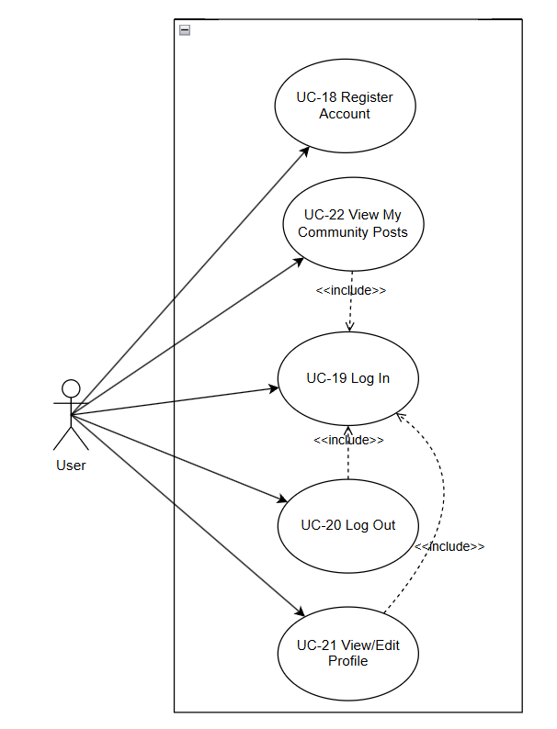

2.2 User Requirement Specification
URS‑18 – Register Account
User can register new accounts with different methods (email address or phone number).
User can enter the received verification code on the page, then set a password (password must contain both uppercase and lowercase letters), fill in the display name (name only allows English characters) and select the interface language.
URS‑19 – Log In
User can log in to the system by entering their registered email address/phone number and password.
URS‑20 – Log Out
User can log out from the system by clicking a logout button, and then they are redirected to the login page and must log in again to access the system.
URS‑21 – View and Edit Profile
User can open their personal profile page to view their stored account information, including display name, avatar, and preferred interface language.
User can edit any of these profile fields by entering new values and submitting the changes.
URS‑22 – View My Community Posts
User can open a dedicated list page under their profile to view all community posts created by their current account.
User can see each post’s title, publication time and current moderation status (published, pending review, or rejected) on this list page.
User Journey
